Discrepancy Between Traditional and Online Intensities – Revisiting the Relation Between Two Different Macroseismic Datasets in Belgium.
B. Neefs¹, K. Van Noten¹
(1) Royal Observatory of Belgium, Uccle, Belgium, Ben.Neefs@seismology.be

Research highlights
A significant underestimation of the traditional intensity data for the only event in Belgium for which both traditional and online intensity data is available, uncovers a large discrepancy between the two macroseismic datasets with major implications for at least decades of collected macroseismic data.

Introduction
Belgian macroseismic data consists of traditional macroseismic data, collected through single communal macroseismic questionnaires for each affected Belgian municipality, and online collected macroseismic data since 2002, based on the “Did You Feel It?” (DYFI) procedure of the USGS (Wald et al., 1999). The M_{L} 5.0 Alsdorf-Eschweiler (AE) 2002-07-22 event took place in the early morning (07:45 AM) with its epicenter located in Western Germany. The event was assigned a maximal intensity of VI on the EMS98 intensity scale and was widely felt in Germany and Belgium (Hinzen, 2005). It is the only event for which both traditional and online intensity data are available in Belgium. Camelbeeck et al. (2003) briefly compared the two data types and argued that both procedures resulted in a similar macroseismic field. The main differences were that the online procedure results in 1) more homogeneous intensity results for adjacent municipalities, 2) a larger felt radius, and 3) a lower number of observations of the maximal intensity IV, on the EMS98 intensity scale, observed in Belgium. A recent review of the traditional macroseismic database (Neefs et al., 2022), however, shows a significant and consistent underestimation of the traditional data for the AE event in Belgium. Consequently, the comparison of Camelbeeck et al. (2003) may no longer be valid. Furthermore, up to recently, the common practice at the ROB to process online macroseismic data was, first, to compute the intensity of each individual submission, and second, to average intensities within each municipality. In the current procedure, aggregation is applied by first grouping observations within each municipality and then assigning a single intensity to it. Here, we reevaluate the traditional intensity data of the AE event by assessing intensity automatically by mimicking “expert judgement” and comparing it with the new online intensity data obtained by aggregation.
The original Alsdorf-Eschweiler 2002 earthquake macroseismic datasets
The Royal Observatory of Belgium actively collects macroseismic intensity data of earthquakes affecting the Belgian territory since 1925 at the latest (Fourmarier and Legraye, 1926), by sending official questionnaires to the mayors of selected Belgian municipalities. While officially still in use, the questionnaire for the AE event was the last to be sent out, due to a lack of significant events in the past two decades and is thus the most recent event for which traditional data are available. The questionnaire was sent to each municipality in Belgium and 500 out of 589 answers were received. These were analyzed, and intensities were assigned manually by expert judgement.
On the date of the AE earthquake, the online macroseismic data collection application of the ROB was launched. The USGS DYFI algorithm was used for intensity computation, with the only difference of not using aggregation. The web address of the online questionnaire was shared through media and in total 6193 submissions were received, of which 215 were discarded due to inconsistency issues or unknown locations.
Both traditional and online macroseismic data are briefly described in Camelbeeck et al. (2003) and a maximal macroseismic intensity of IV was assigned to Belgium. Their results are reproduced in Figure 1, with the minor difference that we use intensity ranges (e.g. III-IV), while the authors of the original paper opted to only use the minimum intensity values instead. The macroseismic field for both data types are rather similar. The most significant difference is the higher online intensities at larger distances in the west of the country where traditional data shows dominantly not felt intensities.
As part of a large-scale review of the 20th century Belgian traditional macroseismic database, an inconsistency was discovered for the macroseismic intensity data for the AE event. As intensity assignment is subjective, different seismologists may assign slightly different intensities with the same information, the discrepancy between the original and the reviewed data for this event is remarkable. Intensity assignments for many municipalities are consistently one full intensity degree in the reviewed data.
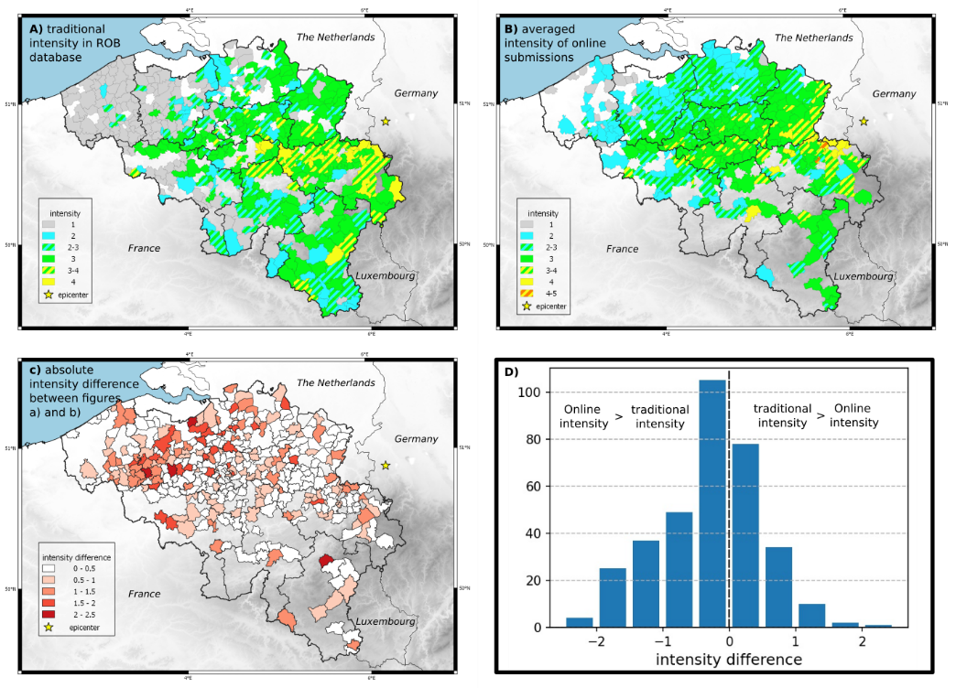
Figure 1. Original macroseismic datasets of the M_{L} 5.0 Alsdorf-Eschweiler 2002-07-22 earthquake and relation between A) traditional municipal intensities and B) online intensities. C) Mapped intensity difference and D) histogram representation for municipalities with both types of macroseismic data.

Creating new AE earthquake macroseismic intensity datasets
To visualize the discrepancy between the originally assigned intensity and the answers on the questionnaires, the questionnaires have been reanalyzed automatically by a new algorithm designed to mimic "expert judgement" and to be in accordance with other traditional intensity datasets from older events. The algorithm assigns scores based on the answers of the questionnaires to five new classes for each municipality. These classes are ‘weakly felt’, ‘strongly felt’, ‘weak effects to objects’, ‘strong effects to objects’ and ‘damage’. The scores given to these different classes are used to assign new intensities. For intensities V to VII, the classes ‘strongly felt’, ‘strong effects to objects’ and ‘damage’ are considered, while for intensities II-IV, the ‘weakly felt’ and ‘weak effects to objects” are used. The algorithm starts with assuming the highest intensity considered, intensity VII. If the requirements for intensity VII are not met, the algorithm continues with intensity VI, etc., until the satisfied intensity with the score is computed. The weights assigned to each question and the thresholds needed for each intensity have been modified to correlate the results with expert judgment. Compared to Camelbeeck et al. (2002), aggregation was used for online intensities, and only municipalities with three or more accepted submissions were considered.

Results
Comparing the original (Figure 1) and revised (Figure 2) datasets show a large discrepancy for the traditional intensities. For large parts of the country, the intensity increased with a full intensity value. While intensity IV is only assigned to a few municipalities originally, the revised dataset shows intensity IV for most municipalities. The maximal intensity is increased to V for three municipalities and twelve municipalities were assigned intensity IV-V. The number of intensities II and III have been drastically reduced. The differences between the original and revised online intensities are less drastic as aggregation results in a slight intensity increase at closer epicentral distances and a slight decrease at larger distances. Comparing the revised datasets uncovers a large discrepancy in assigned intensities (Figures 2C and 2D) all throughout the country.

Discussion and conclusions
For the last two decades, the collection of macroseismic intensity data in Belgium only occurred through the online application of the ROB with the assumption that online intensity roughly equals traditional intensity. By revising both traditional and online intensities, this assumption may no longer be valid.
Through automation, the traditional intensity dataset now reports intensities up to intensity V, which corresponds well to the reported light damages and panic among the inhabitants, according to the European Macroseismic scale (EMS98; Grünthal, 1998). The large number of intensity IV values in the revised traditional dataset may look inflated, but all questionnaires from these municipalities indicated that 1) many people felt the earthquake or that at least a few people felt it outside, and 2) multiple effects were observed to objects such as swinging, shaking, vibrating, rattling or moving. A known issue with the traditional questionnaires is that there is no information on the quantity of people that observed a certain effect. Indicating the occurrence of a certain earthquake effect might be based on the testimony of a single individual or it could have been observed by every household. The assumption is that the questionnaire is representative

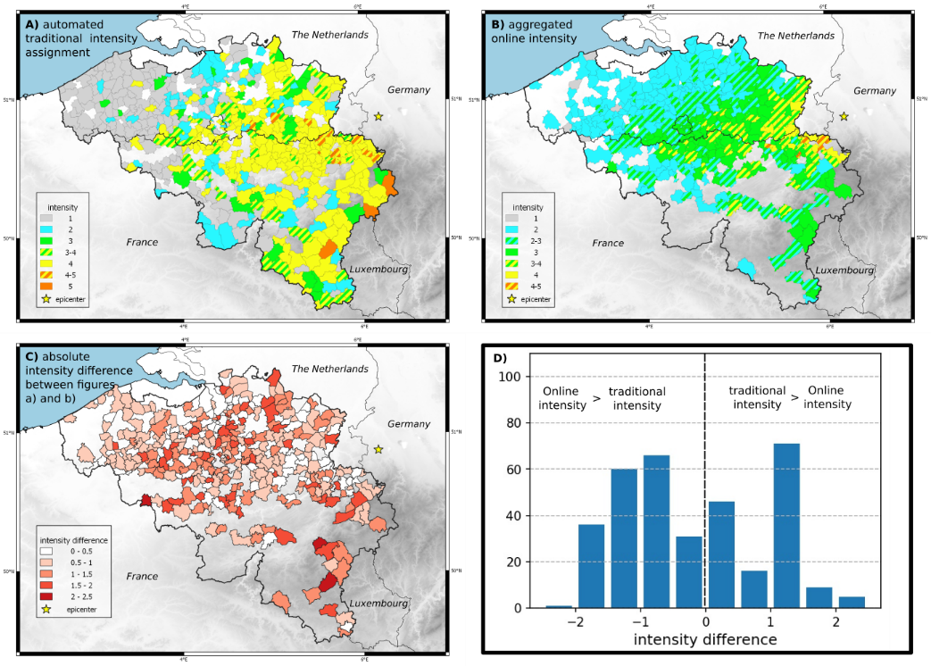
Figure 2. Revised macroseismic intensity datasets for the M_{L} 5.0 Alsdorf-Eschweiler 2002-07-22 earthquake. A) Automated traditional intensities. B) Aggregated online intensities. C) Mapped intensity difference and D) histogram representation for municipalities for both types of macroseismic datasets
for the entire municipality and its quality will depend on the effort of the official completing the survey to inform himself about the effects of the earthquake. The benefit of the online questionnaires is that the quantity of the occurrence of all effects are available.
The large discrepancy between the revised traditional and online datasets hints to at least one of them being erroneous or inaccurate. The revised traditional dataset is now more in accordance with how traditional questionnaires have been analyzed at the ROB throughout the 20th century. Then again, the online DYFI procedure is a widely used and tested procedure with satisfactory correlations to traditional intensity data from all over the world (e.g., Wald et al., 2010). Even though the DYFI application has been calibrated to traditional MMI intensities from the US and not EMS98 intensities, both scales can be considered equivalent (Musson, 2010).
In conclusion, the revision of traditional and online intensities of the ML 5.0 Alsdorf-Eschweiler 2002-07-22 event uncovers a significant discrepancy between both datatypes. While its cause is unknown, if the discrepancy between the two data types is indeed as significant as described here, this may have major implications for either the last two decades of online collected intensity data or an entire century of traditional macroseismic data.

References
Camelbeeck, T., Van Camp, M., Martin, H., Van De Putte, W., Béatse, H., Bukasa, B., Castelein, S., Collin, F., Hendrickx M., El Bouch, A., Petermans, T., Snissaert, M., Vanneste, K., Verbeiren, R., 2003. Les effets du tremblement de Terre du 22 Juillet 2002. Ciel et Terre 119-1.
Fourmarier, P., Legraye, M., 1926. Le tremblement de terre du 23 février 1925 dans le Limbourg et la province de Liège. Annales de la société géologique de Belgique 48.
Grünthal, G. (Ed.), 1998. European Macroseismic Scale 1998 (EMS-98). European Seismological Commission, Working Group Macroseismic Scale, Cahiers du Centre Européen de Géodynamique et de Séismologie 15, Luxembourg.
Hinzen, K.G., 2005. Ground motion parameters of the July 22, 2002 ML 4.9 Alsdorf (Germany) Earthquake. Bollettino di Geofysica Teorica ed Applicata 46-4, 308-318.
Neefs, B., Van Noten, K., Camelbeeck, T., 2002. Towards a harmonized macroseismic database for Belgium. Proceedings of the 3rd European Conference on Earthquake Engineering & Seismology. Bucharest, Romania.
Wald, D.J., Quitoriano, V., Dengler, L., Dewey, J.W., 1999. Utilization of the internet for rapid community intensity maps. Seismological Research Letters 70, 680-693.

